# Weekly Contribution – 14/03/21

**Created most of the user stories on the trello page, see the screenshot below:**

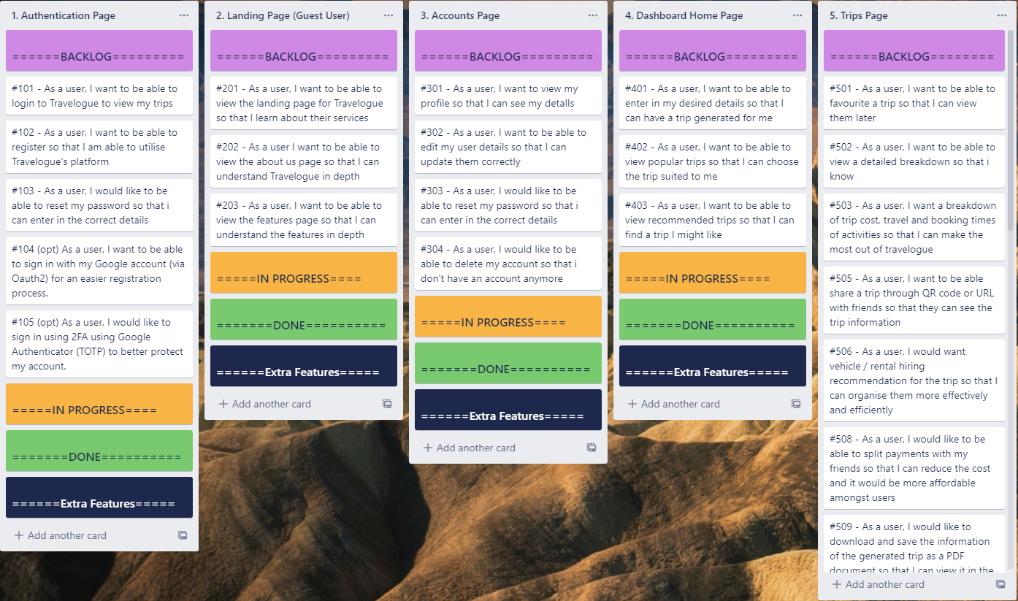

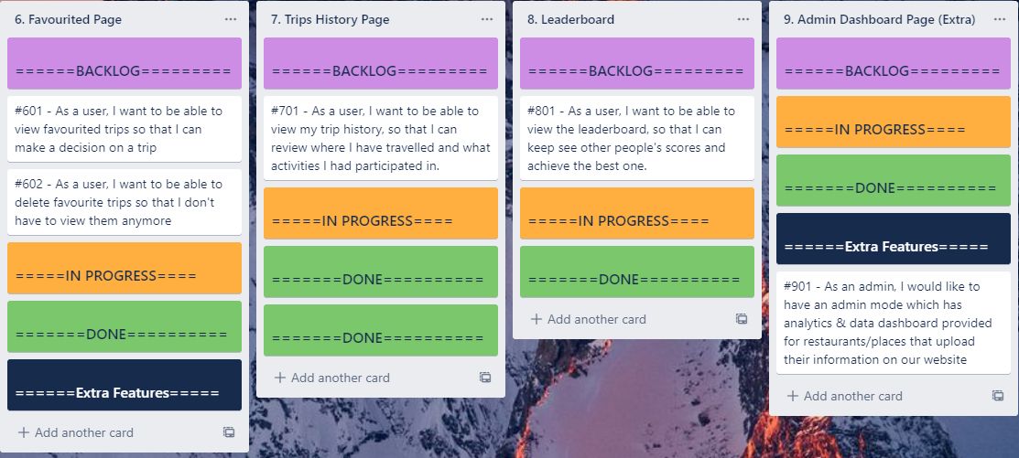

**In the team charter I worked on the following sections:**

* Project Timeline
* Functionality Composition
* Team Information

See screenshots below:

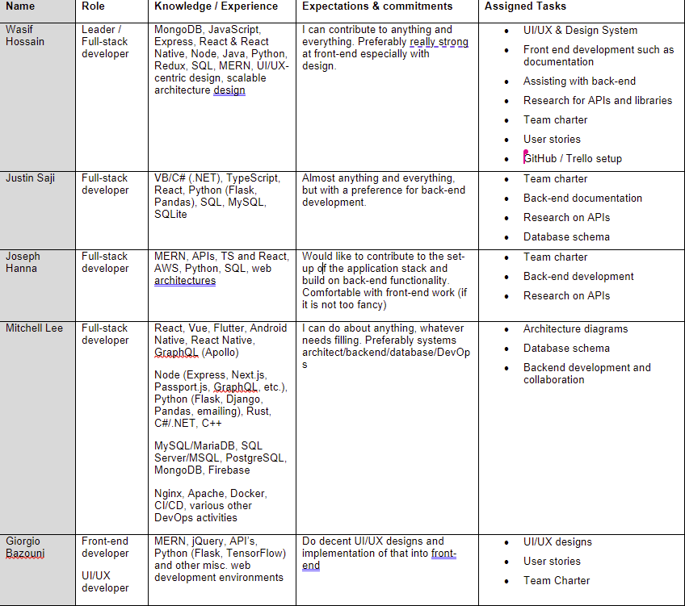

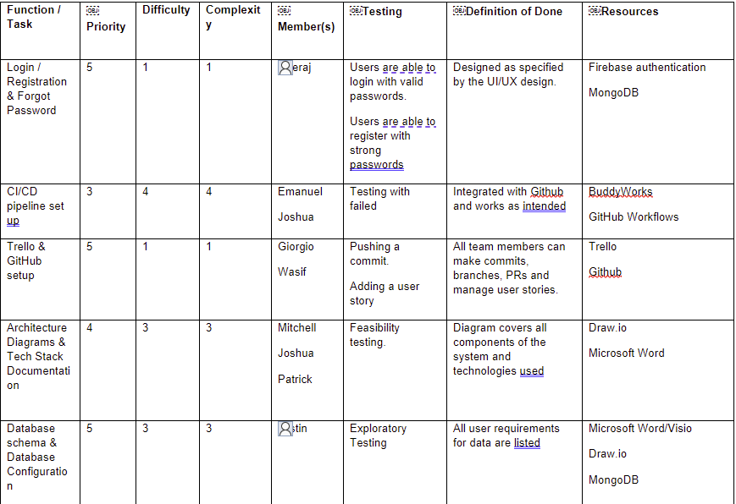

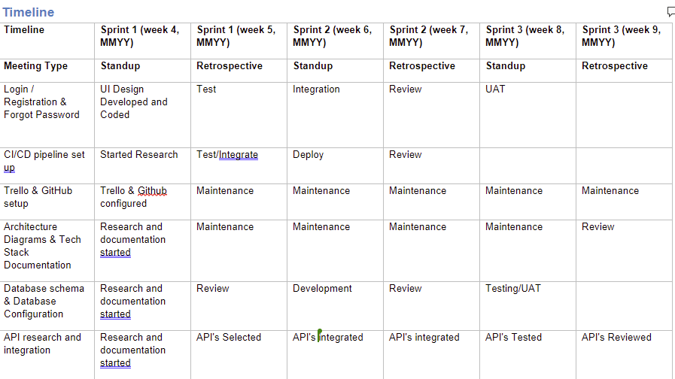

**Worked on and completed the UI/UX for the Login, Registration and Forgot Password Pages:**

